How to install MySql in Windows

This document will show you step by step how to install MySql in few minutes.

Step1
Download the file from below link and install the .msi file in your desktop.

DOWNLOAD LINK

Step2
Install the software and check in start option with name mysql-installer

After opening the software you may get something like below screenshot.
Click on Add as highlighted below.

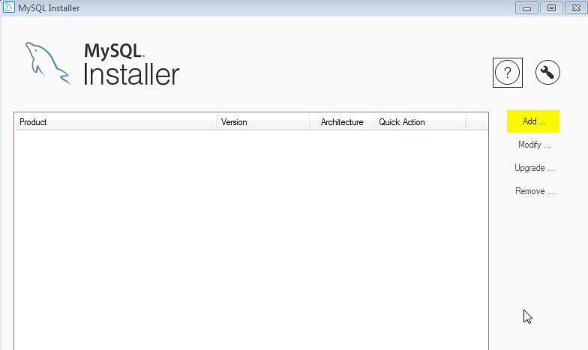

Step3
Let the default settings be selected. And simply click on Next
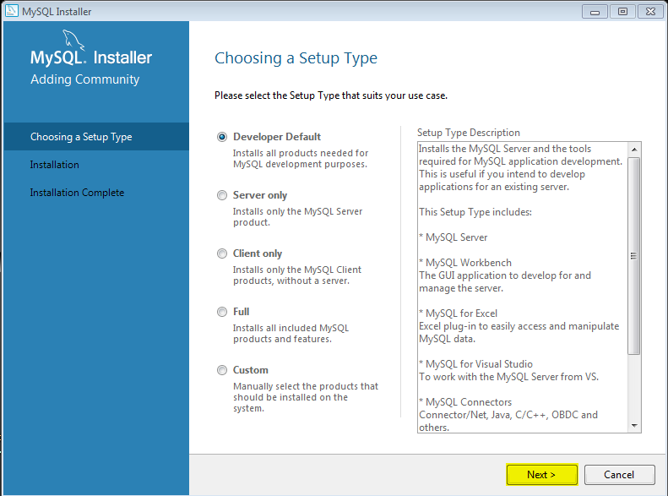

You will be further shown dependencies,These are extra Advanced Dependencies.
Which you might need depending on your area of interest. Select you type of dependencies and click on check. This will download needed file.

Note: the setup will download the basic dependencies by default.

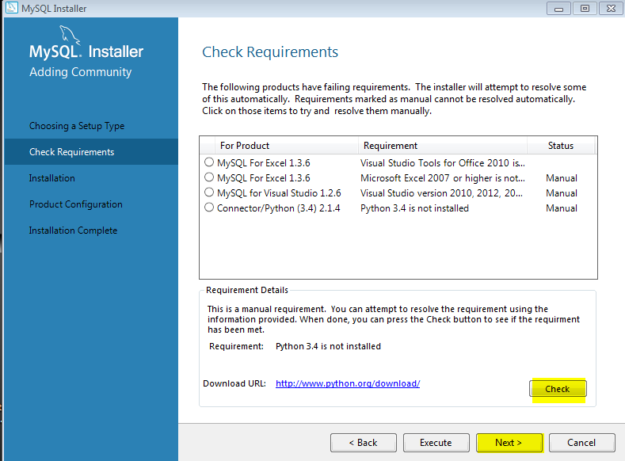

Click on Execute to download listed things.

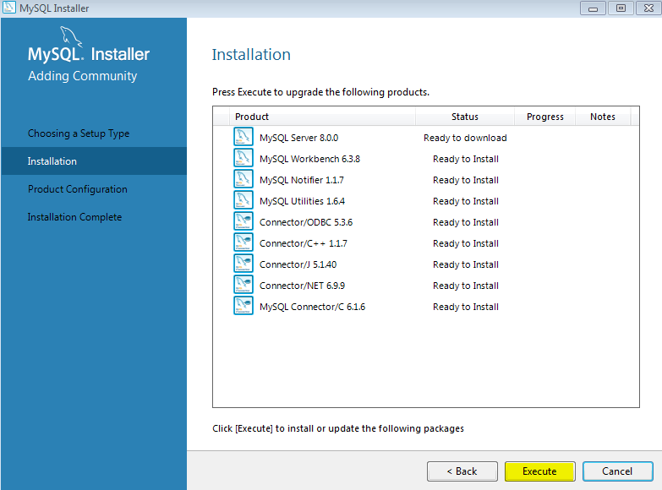

Again click Next.

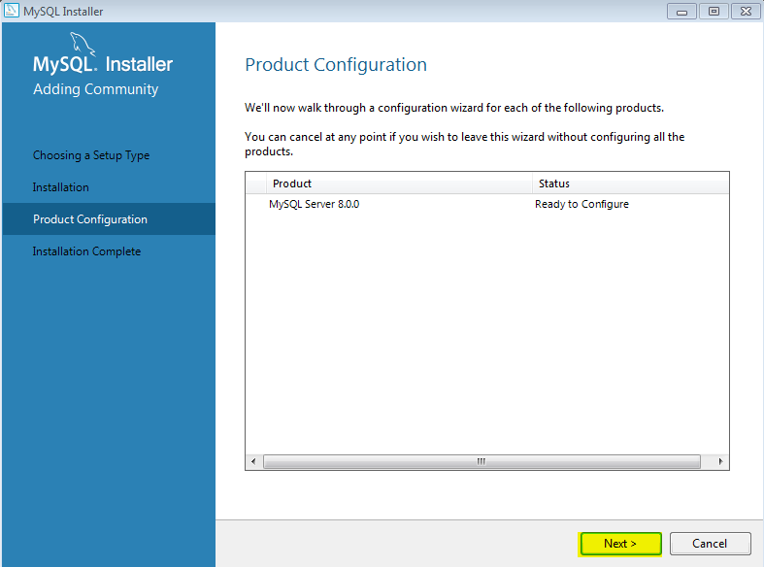

Click next.

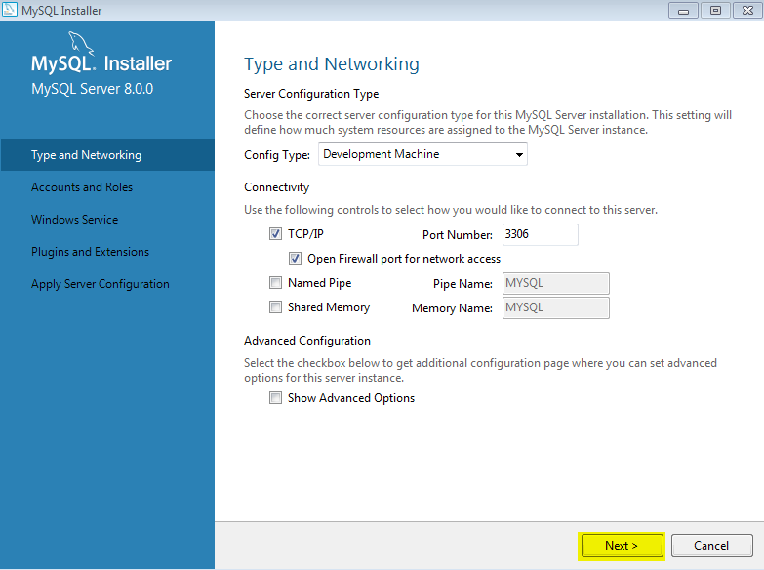

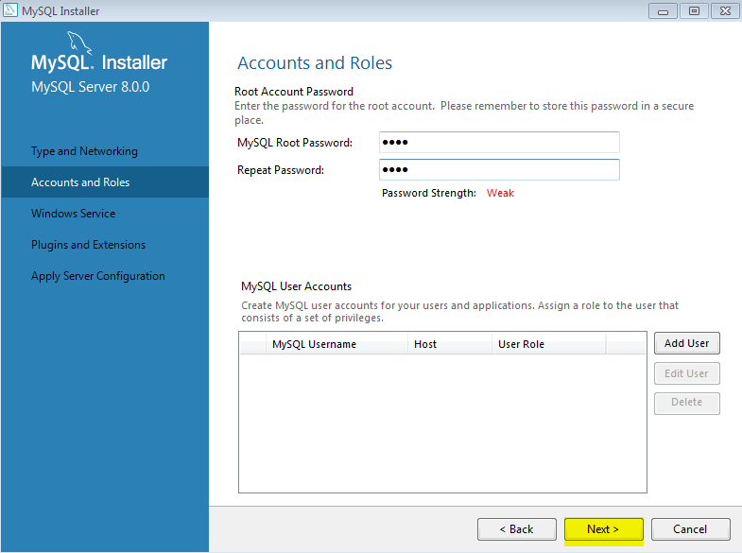

Click Next

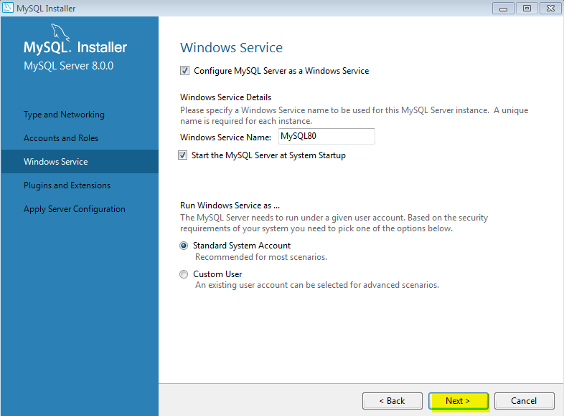
Click Next.

Cliclk Next.

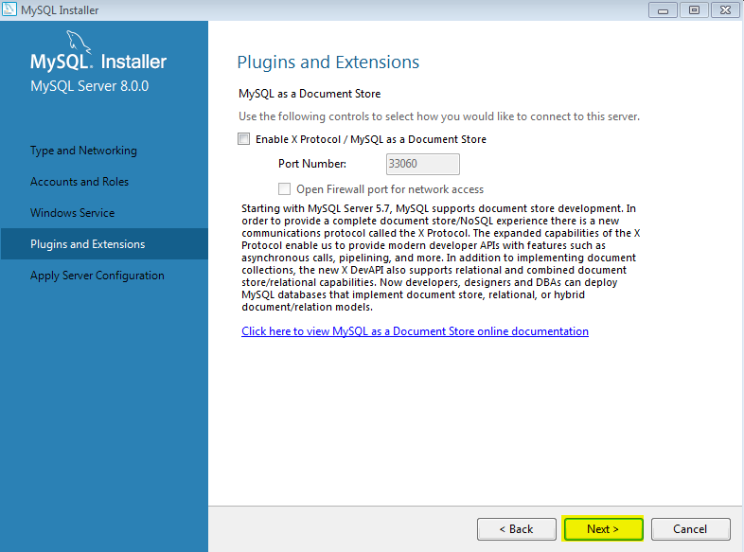

Click Next.

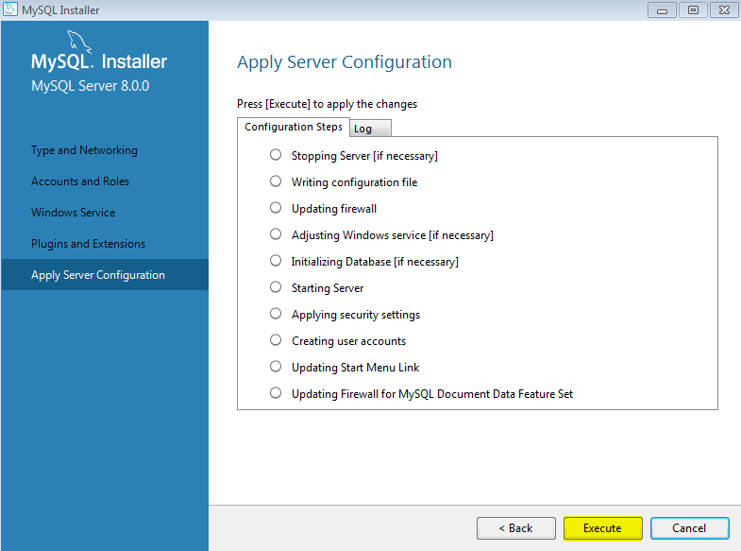

Click Next

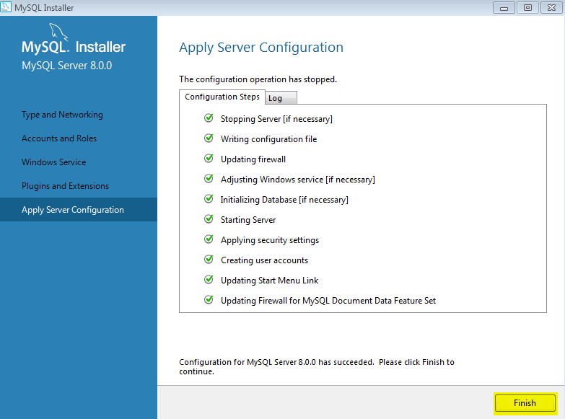

Click Next.

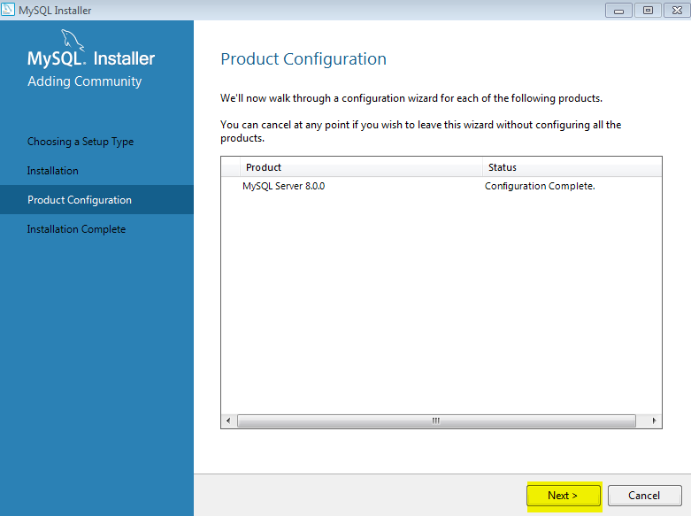

Click Finish.
This will start the Mysql WorkBench.

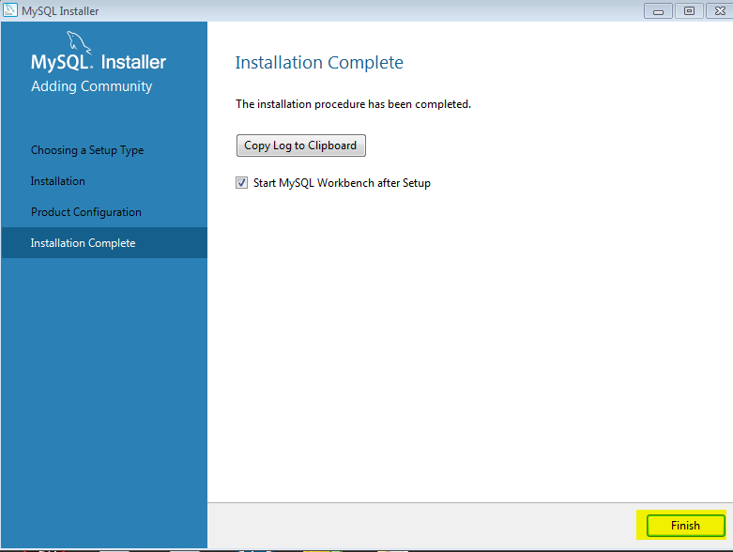

The work Beck Is now Up. Select t

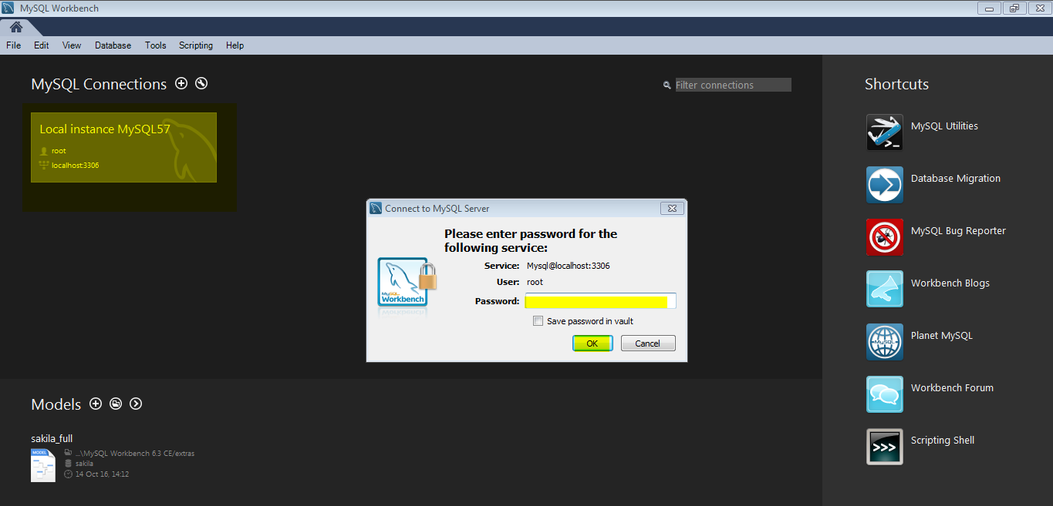

Write your query and Run.

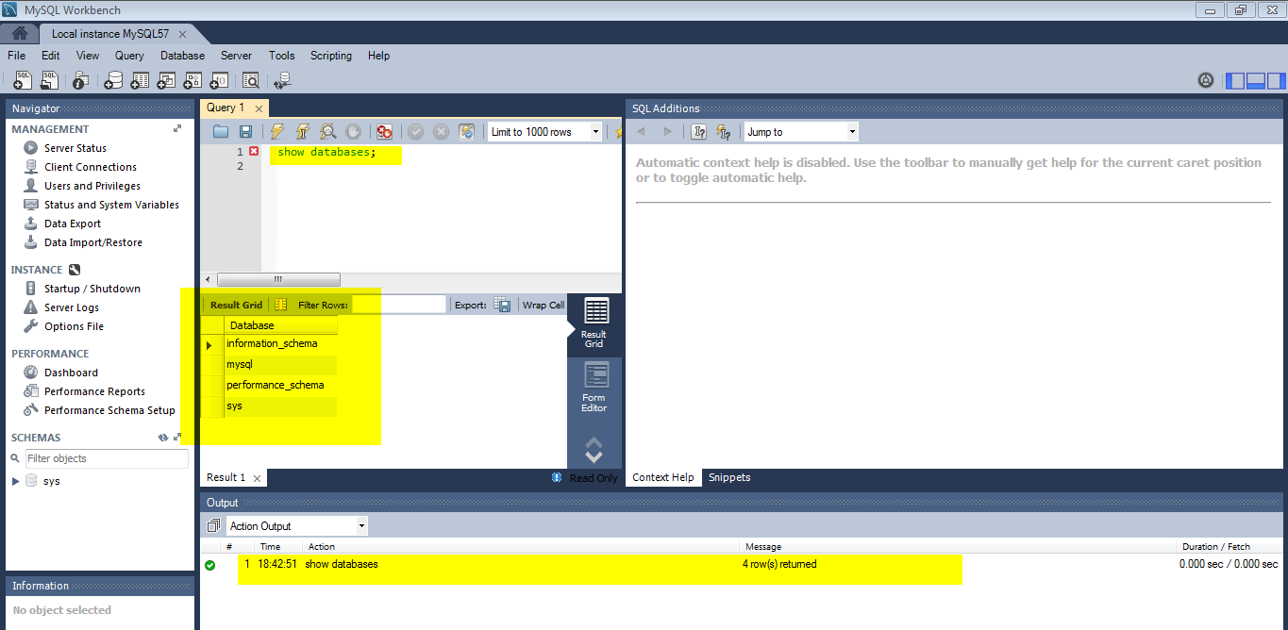

Workbench is ready to Use.

